TITLE OF THE COMMUNICATION: WRITTEN IN THE STYLE “TITLE” USING ARIAL FONT WITH FONT SIZE 12 AND BOLD

Name of author 1
Company/Group/University to which you belong
Name of the department/unit/laboratory in which you carry out your activity
Position in the company, group or university
Full postal address (Street, province, city, post code, country)
E-mail
Telephone (with country and area codes)

Name of author 2
Company/Group/University to which you belong
Name of the department/unit/laboratory in which you carry out your activity
Position in the company, group or university
Full postal address (Street, province, city, post code, country)
E-mail
Telephone (with country and area codes)

Name of author 3
Company/Group/University to which you belong
Name of the department/unit/laboratory in which you carry out your activity
Position in the company, group or university
Full postal address (Street, province, city, post code, country)
E-mail
Telephone (with country and area codes)

Key words: word 1, word 2, word 3, word 4, word 5, word 6. (Use as a minimum three words and maximum six words)

Abstract

The abstract should clarify the objectives of the communication, the methodology, the data used and the main conclusions. Remember that the recommended extension of this section is 600 words.

Introduction and first section in style “Title 1”

Here the text of the first section, remember that the use of bold in the text is not allowed, if you want to highlight phrase used italics. Remember to always refer to the tables and figures in the text, exp.: in Table 1 details the array of styles allowed.

Table 1. Styles (style "Titles of tables or figures)
Source: Xxxxx

Subtitle of section in style “Title 2”

Here the text of subsection. Remember that you can only have figures and tables, figures include graphs, drawings, maps, photographs and other artwork. Remember that the notes should go to the text footer, not the end.

"This is textual quotation from the text of another author published in another paper (Surname, year of publication, pp. 25)

Figure 1. Map of a section of Barcelona
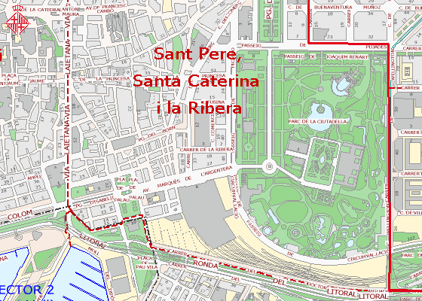
Source: Guia Urbana de la Ciutat (Ajuntament de Barcelona)

Here the text continues.

Bibliography

GRAHAM, Sheila. College of one. New York : Viking, 1967.
GRAHAM, Sheila. Review of College Comtemporaries. On Urban Studies, 1975, vol. III, núm. 4, p.243-256.

General conditions

The definitive version of the communications, in Spanish or English, must be between 5,500-6,500 words in length, including the bibliographic references. In the case of including images, the total length of the communication must not exceed 15 pages. The text must be written on A4 sized pages, with Arial 10 lettering, 1.15 spacing, with upper and lower margins of 3cm and side margins of 2.5 cm. Communications will only be accepted in Microsoft Word (*.doc) format.

? Footer

